**Live Lessons on Microsoft Teams**

Microsoft Teams is used to have online lessons, which include audio, PowerPoint, video and screen sharing. Teams allows you to communicate with your teachers.

On Seesaw there will be a link to access a live lesson using Microsoft Teams. This link will be in the blended learning folder.

You do not need to have a login to use Microsoft Teams.

Web browsers that support Teams:

* Microsoft Edge – latest version 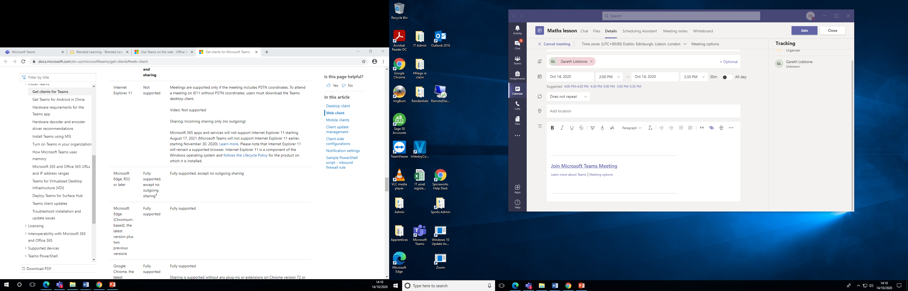
* Google Chrome 

On a mobile device or tablet you will need to download the Microsoft Teams app. 

Using a PC:

On the day of the lesson you will need to click on the link, which will then open the web browser with the following screen.

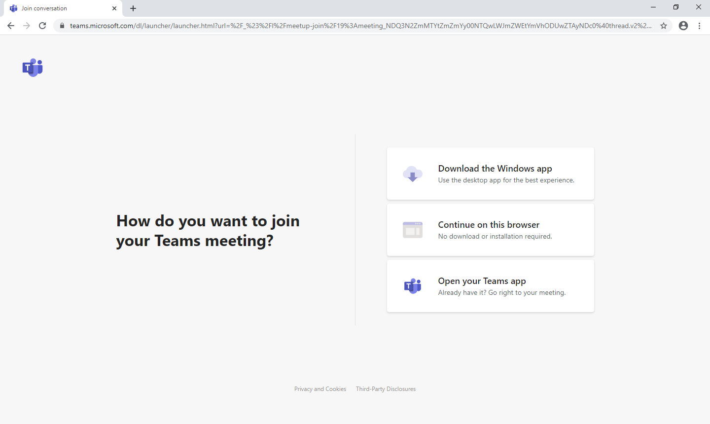

If you have the Teams app installed you can click open your Teams app. If you don’t have the app you can click continue on this browser.

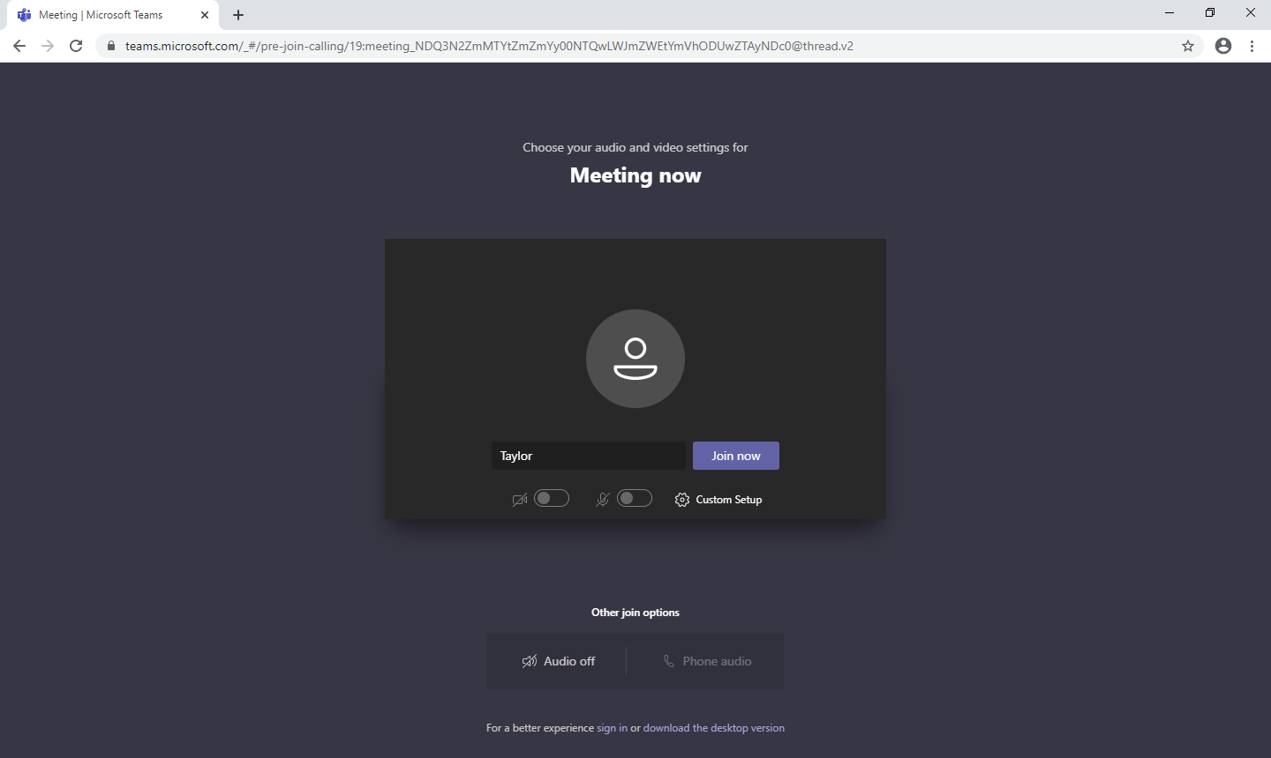

You will then need to enter your name and click ‘Join now’. At this point, make sure you have your camera on and microphone switched off.

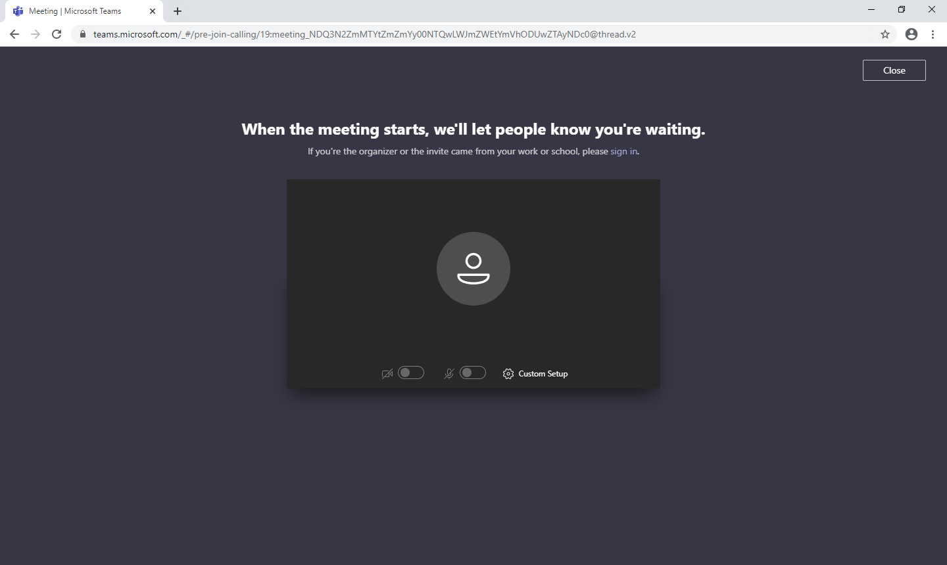

You will then see the screen above until your child’s teacher admits you into the meeting.

If you are using a mobile or tablet device, you will need to download the free Microsoft Teams app from the app store. Then follow the steps outlined below.

Click on the link, this will then open the Microsoft Teams app as shown below



Click ‘Join as a guest’ and enter your name



You will then be held in the waiting room until your child’s class teacher admits you into the meeting.



If you have trouble turning the camera on when using the app, you will need to leave the meeting once you have been admitted and re-join, this will then allow you to turn the camera on. You will be able to unmute yourself and tell the teacher this is what you are doing.